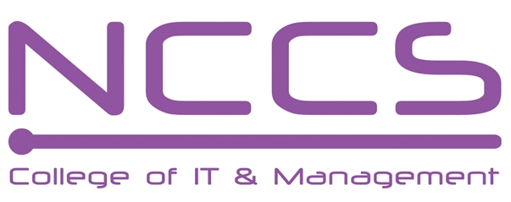
National College of Computer Studies
(NCCS-College of IT & Management)

Pre Board Examination (2021)
BSc.CSIT/First Semester/ CSC-109 : Introduction to Information Technology

Candidates are required to answer the questions in their own words as far as practicable.

Full Marks: 60
Pass Marks: 30
Time: 3 Hours
Set B

Long Questions:
Attempt any two Questions: [2×10=20]
- What is operating system? Discuss functions and classifications of operating system.
- Discuss different types of computer software with example.
- What is switching? How can you differentiate packet switching from circuit? What are advantage of optical fibers?
Short Questions:
Attempt any eight questions [8×5=40]
- Explain briefly about different generation of computer.
- What are the major characteristics of data in a database?
- Differentiate between compiler, interpreter and assembler.
- What is email and how it works?
- Discuss data warehousing and data mining along with advantages.
- What are the different protocols available on the Internet?
- Explain briefly about E-governance.
- What are the components of Multimedia?
- Briefly explain about Programmed I/O and Direct Memory Access (DMA).
- Do the following conversion
a.) 4.25 = (……..) 2 b.) Subtract 1101-1110 using 1’s and 2’s complement
********
Note: Please send your answer sheet to the following e-mail address.
To: csit10batch@nccs.edu.np
CC: khushi.soni4u@gmail.com

